9a output:

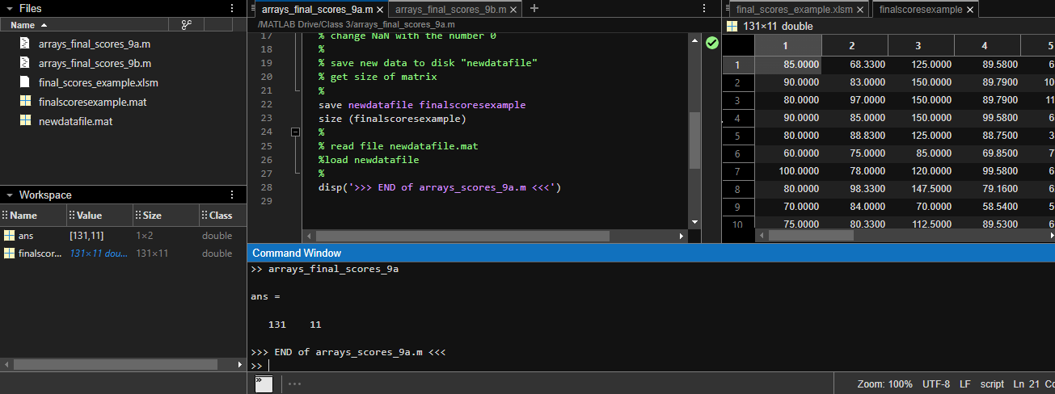

9b output:

Figure1:

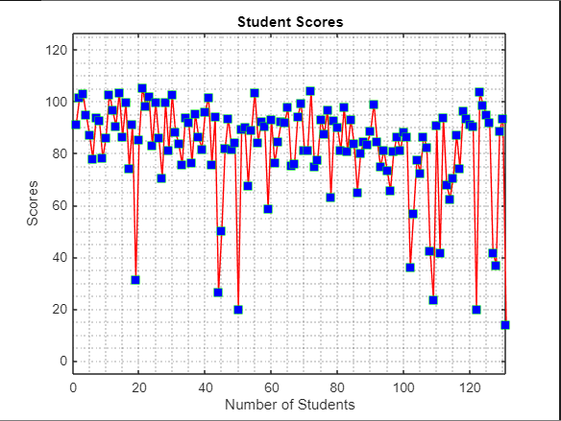

Figure2:

Figure3:

Figure4:

Figure5:

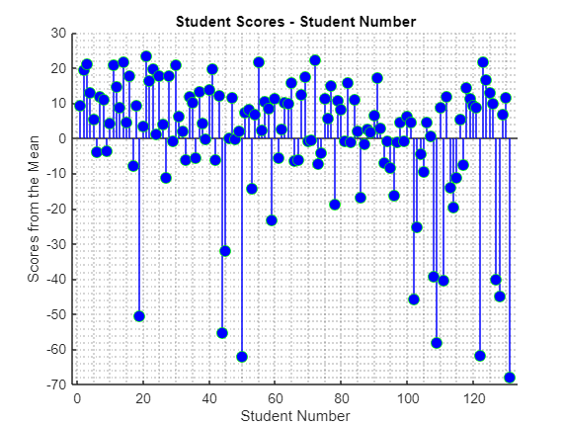

Figure6:

